EMOJI MATCH

By Ethan Chung



User’s Guide

TAble of  
Contents

Basics Overview 1

System Requirements 1

Main Menu 2

Starting game modes 3

Emoji Match – How to play 4

# Basics Overview

Emoji Match is a simple game of memory which requires the user to match cards by flipping two cards. The user is required to memorise the card places and try to match all the cards. The aim is to match all the cards in the fastest possible amount of time.

## System Requirements

To run the game, simply open the file by double clicking the Emoji Match.exe. If that doesn’t work, then try by right clicking the file and running it as the administrator. The requirements for the memory game are as follows:

* Any Intel or AMD-based CPU produced after 2016
* At least 2GB of RAM
* At least 80MB of storage
* Windows 7 or higher
* .NET Framework 4.0 or higher installed
* Good quality speakers/headphones

## Main Menu

When the user launches the Emoji Match, they are greeted with the main menu screen, which looks like this below:

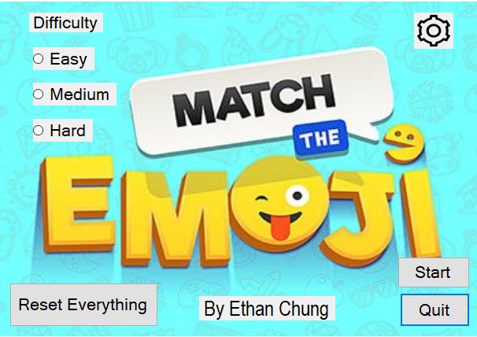

The user would need to pick the difficulty of the game to play

The start button starts the game difficulty chosen, otherwise would prompt user to pick a difficulty. The quit button closes the application

The reset button was put to reset all player data hi scores. It is highly recommended to be pressed when playing for the first time

The Settings button displays the volume adjustments for the game

## Starting game modes

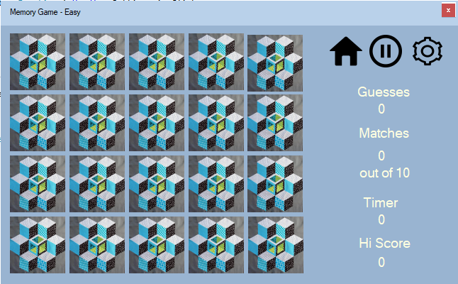

These are navigation buttons, home, which goes back to the main menu settings, which opens the volume adjustments and pause, which temporarily pauses the game.

A cross button on the top right-hand corner quits the game and closes the application. There is an are you sure message box when the button is pressed

There is also a draggable top slider found in every difficulty

This is easy mode, which consists of 20 cards which is 10 pairs

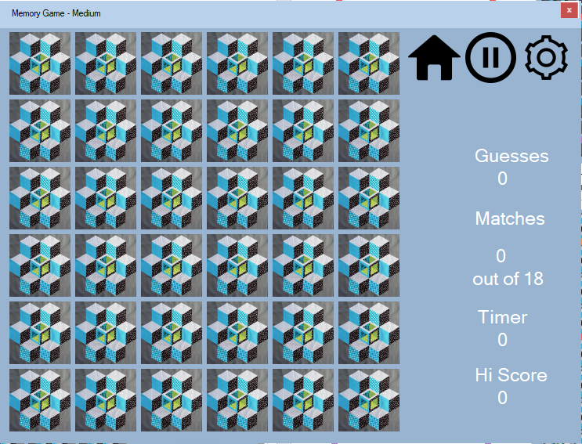

This is medium mode, which consists of 36 cards which is 18 pairs

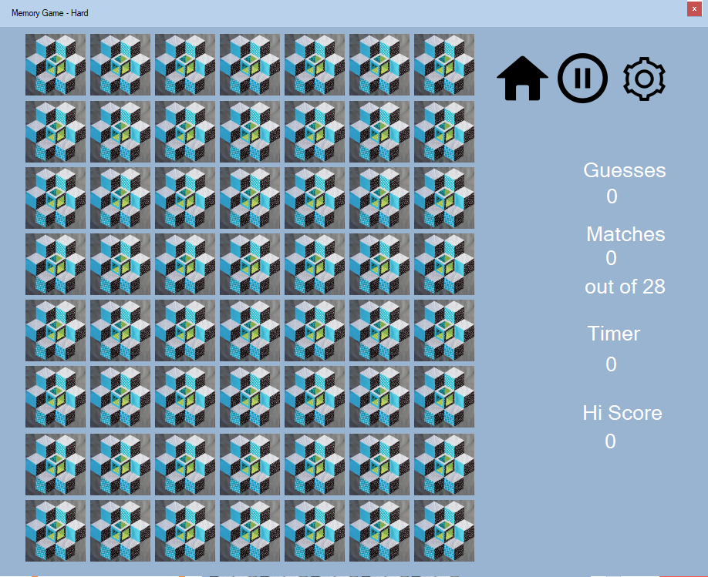

This is hard mode, which consists of 56 cards which is 28 pairs

## Emoji Match – How to play

Memory Match is classic game in which you reveal 2 emoji pictures at a time. You must match pairs of emoji pictures with each other to win. My Easy mode is played on a 20 card board with 10 pairs, in medium mode, there are 36 cards, with 18 pairs. In hard mode, there are 56 cards, with 28 pairs. Every pair of cards revealed would be counted as a guess and displayed on the right-hand side.

To start, choose a difficulty and press the start button (). The background music would play when starting the memory game. When playing for the first time, a message box would appear when finished matching all the pairs. This would set the high score as the timer value of that game. When the user plays it again, the high score would be displayed on the right-hand side and the timer would turn red when more than the high score.

To restart, press the home button () and press start on the main menu. This would reset the current game.

To pause the game, press the pause button () on the top right-hand side of the form. This screen would be seen below when playing easy:

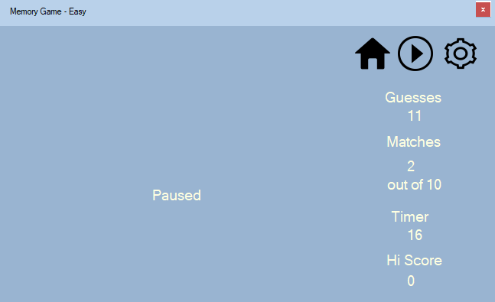

To resume the game, press the button that says click the play button and you would be back to the current game.

To move the form around, click the lighter blue bar on the top of the form and drag it around as desired.



To adjust the volume, press the cog wheel on the top right of any form, and a control would appear in the form.



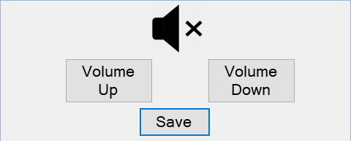

Volume up button increases the volume and volume down decreases the volume. The mute button mutes all sounds. When pressed again (), it would unmute. To close the control, press the save button.